Software Requirements Specification
for
City Corporation Complaint Box and Monitoring System
Tausif Ahmed Turzo(160207)
Mostofa Rakib Raihan(160220)
Khulna University
01.08.2018
Table of Contents
Table of Contents ii
Revision History ii
1. Introduction 1
1.1 Purpose 1
1.2 Document Conventions 1
1.3 Intended Audience and Reading Suggestions 1
1.4 Product Scope 1
1.5 References 1
2. Overall Description 2
2.1 Product Perspective 2
2.2 Product Functions 2
2.3 User Classes and Characteristics 2
2.4 Operating Environment 2
2.5 Design and Implementation Constraints 2
2.6 User Documentation 2
2.7 Assumptions and Dependencies 3
3. External Interface Requirements 3
3.1 User Interfaces 3
3.2 Hardware Interfaces 3
3.3 Software Interfaces 3
3.4 Communications Interfaces 3
4. System Features 4
4.1 System Feature 1 5
4.2 System Feature 2 (and so on) 5
5. Other Nonfunctional Requirements 6
5.1 Safety Requirements 6
5.2 Security Requirements 6
5.3 Software Quality Attributes 6
5.4 Business Rules 6
6. Questionnaire 6
7. Use Case 8
8. E-R Diagram……………………………………………………………...…………………14
9. Class Diagram…………………………………………………………....…………………15
10. Detail Designs…………………………………………………………...…………………16
11. User Interface…………………………………………………………...…………………18

Revision History

Name | Date | Reason For Changes | Version
SRS | 7/8/2018 |  | 1.0
SRS | 11/9/2018 | Questionnaire & Use Case needed to be added | 1.1
SRS | 6/10/2018 | Use Cases Updated | 1.2
SRS | 28/10/2018 | ER Diagram, Class Diagram, Detail Designs, UI  added | 1.3

Introduction

Purpose
As the pace of urbanization is getting faster day by day, it is getting tougher to keep track of all the problems of a city. Many issues are affecting day to day lives of the residents of a city. So, we are developing a product named ‘City Corporation Complaint Box and Monitoring System’. The purpose of this product is to create a digital place for all the complaints of residents of a city and get them monitored by proper authority. So that, if someone is facing any issues, he can get solution in shortest possible time.

Document Conventions
The document is divided into five parts. Each part containing sections. The sections are also divided into some subsections. The sections are highlighted with bold letters. Every sections and subsections contain their own descriptions.

Intended Audience and Reading Suggestions
This document is intended for developers, city corporation authorities, citizens, testers and documentation writers.

- Developers: Developers need this document, to understand the product and for future development.

- City corporation authorities: City corporation authorities should read this document, so that they can have a better understanding of the functionalities of this product. This will make the works of city corporation authorities easier.

- Citizens: Citizens should read this document so that they can know the advantages of using this product and avail themselves of the functionalities.

To understand the paper properly, one have to go through the sections one by one, beginning with the overview section.

Product Scope
The purpose of this product is to make the management of the city corporation activities and complaints easier. It will help the citizens get solution for their problems faster and easier.

References
- https://web.cs.dal.ca/~hawkey/3130/srs_template-ieee.doc
- https://www.tutorialspoint.com/software_engineering/software_requirements.htm

Overall Description

Product Perspective
This product mainly focuses on city corporation activities and solutions of problems. Now a days, populations are increasing faster than ever. As a result, more and more issues are arising. Many of them goes unnoticed from City Corporation. People doesn’t always find proper platform to report their problems. We are developing a product which will help both City Corporation authorities and citizens in solving these problems.

Product Functions
Some main functions of the product are:
- Assigning City Corporation authorities
- Registering and taking complaints from citizens.
- Commenting on the complaints to give opinions or solutions
- Update the progress of the complaints
- Sharing the complaints among authorities of certain section
- Keep track of the progress as a citizen

User Classes and Characteristics
Mainly there will be two kinds of users. They are:
- Admin
Admin will assign who the City Corporation authorities are. Admin will also approve the registration of citizens.

- City Corporation Authority
City Corporation authority can view the complaints of citizens, forward the complaint to higher authority if needed, comment on the complaints, update the progress of actions between ‘pending’ , ‘work-in-progress’ and ‘solved’.

- Citizen
Citizen can issue complaints in the complaints box and track the progress.

Operating Environment
Operating environment for our system:
- Database
- Operating System: Windows 10
- Platform: .NET
- Software: Visual Studio 2017

Design and Implementation Constraints
Developers can include more features in future. Admin and City Corporation Authority cannot delete any complaints. Admin will verify the citizens during registration. Upon registration there won’t be any blocking option.

User Documentation
To use the product properly, there will be various components to help the user. Some of them are:
- User Manual: Will be attached as the product completes
- Online Help: There will be a report option and an FAQ in the product.

Assumptions and Dependencies
- Complaints might remain unsolved for longer periods if not given time limits
- Authority might give false update about progress

External Interface Requirements

User Interfaces
User interface should have:
- Registration and login option as citizens.
- Login options as City Corporation Authority
- A complaint box for issuing complaints
- Comment box to comment opinions or solutions regarding the complaints
- A progress bar for tracking progress

Hardware Interfaces
- Windows 10
- Browser that supports HTML, CSS .

Software Interfaces
Operating System | We have chosen Windows operating System .
Database | For storing data we have chosen SQL database.
ASP.NET | We have chosen ASP.NET framework.

Communications Interfaces
The project will support all types of web browser

System Features
Our project is city corporation complain box. Here the city people can directly interact with the city corporation works. People will be able to complain about malfunctions and will have clear information about how city corporation is processing the complain and the progress also . Proper details about all project will be provided . The people can review the works and able to give their decision.

System Feature 1

4.1.1 System feature for admin

Login
Verify Citizen
Assign authority

4.1.2 System feature for authority

Can read complaints and can comment

Update progress

Assign workers

4.1.3 System feature for citizen

Can complain

Can see the update

Other Nonfunctional Requirements

Safety Requirements
There is always a possibility of extensive damage to a wide portion of the database due to a disk crash. Therefore, backups should be created time to time.

Security Requirements
Security systems need database storage just like many other applications. However, the
requirements of the security means that admin must choose their database partner carefully.

Software Quality Attributes
• AVAILABILITY: The software should be available to the mass of a city
• CORRECTNESS: The progress of the complaints should be updated correctly.
• MAINTAINABILITY: The Admins and City Corporation authorities should maintain the software regularly.

Questionnaire

For the betterment of our project, we did a Q&A survey. We went Councilors office and met the authority responsible for .And we also asked the civil people about their thinking. We asked them different questions and got to know about the requirements.

The question answer between us and authority is given below :

1 . In which word do you work in Khulna City Corporation?
Ans: Ward no. 19
2. Generally how often you check the complaint box?
Ans: On Sunday and Wednesday.
3 . What are the main problems of existing manual complain box ?
Ans: People are less interested to come here and complain .
4 . If it is digitalized do you think it will be more efficient than the existing one ?

Ans: If people can complain seating in their home then I think we will get more complain and interact with them easily .
5 . Do you think City Corporation have the ability to maintain the online system and manage the huge data?
Ans: Government have the enough manpower. But they have to be trained properly.
6 . Is it really possible to replace the existing system with this online system?
Ans: Why not. The world is developing faster and to cope with the speed I think we have to be digitalized.

The question answer between us and civil person is given below:

1 . In which word do you live in Khulna City Corporation?
Ans: Ward no. 19
2 . How long are you living here?
Ans: Its been 20 years or more .
3 . What types of problems are you facing?
Ans: Basically problems with water line , sewerage line , dustbin , road or problems with neighbor etc.
4 . Did you complained about all the problems you face earlier?
Ans: Not if it is not a big one.
5 . What is the percentage of your solved problems?
Ans: I have complained about the damaged road. But still I can’t see any progress.
6 . Did you face any kind of barrier in time of going City Corporation to complain?
Ans: Its really hard for me to take time from my business to go there and complain. And another one is as I can’t see others complain, I think often that anyone from my society complained before me.
7 . What do you think about Online complain box?
Ans: To be honest I am not satisfied with the existing one. So, if online box can solve the problem then I am okay with it.
8 . Do you have any suggestion or any function to add into this online complain box?
Ans: It should be more dynamic and it should be opened to everybody. So that everybody can see the progress rate of their complain.

Use Case

Authority
Home page

Login

Admin
Verify Citizen

Assign authority

Can read complaints and can comment

Citizen
Update progress

Assign workers

Can complain
Can see the update

Use Case Descriptions

Homepage
Use Case Name | Homepage
Brief Description | The home page provides all necessary page links based on the user accessibility.
Priority | Essential
Trigger | The user select the complaint box link on City Corporation homepage
Precondition | The user must be connected to the internet.
Basic Path | 1. The Server presents the users with the user Home Page.
Alternate Path | Directly enter web address into the address bar
Post condition | User is on the User Home Page
Exception Path | If there is a connection failure, the  City Corporation Server returns to the wait state

Create New Admin Account
Use Case Name | Create new admin account
Brief Description | New admin accounts can be created but they will get approval from main admin by submitting proper documents
Priority | Critical
Trigger | The user choose to create new admin account
Precondition | The user must be connected to the internet.
Basic Path | - The City Corporation Server presents the  user with a form of fields to fill with first name, middle name, last name, job position, email, password.  - Fill in the form and click Create Admin.  - City corporation sever checks to see if all required fields are not empty.  - If the required fields are not empty, the City corporation server creates a new Admin and waits for approval of main admin  - If main admin approves then city corporation server creates a new entry on Admin table of the City corporation Complaint box.  - If any of the required fields are empty, the City Corporation server returns a message and returns to the create new admin form.  - City Corporation server returns the admin to Complaint box homepage.
Alternate Path | N/A
Post condition | New Admin is created in the Admin table of the City Corporation Complaint box users
Exception Path | If the connection is terminated before the form is submitted, the fields are all cleared and the City Corporation Server is returned to the wait state.

Assign Authority
Use case Name | Assign authority
Brief Description | Admin can assign authority for different works and sectors.
Priority | Essential
Trigger | Admin choose to set authority.
Precondition | User are on admin mode, connected to the internet and on the city corporation complaint box homepage.
Basic Path | - The City Corporation Server presents a form with fields of first name, middle name, last name, ward no. , NID no. ,email, contact no. , address to admin for obtaining authorization.  - After assigning authority successfully City Corporation server returns a success message.  - City Corporation Server returns the admin to city corporation complaint box Home page.
Alternate Path | N/A
Post condition | A record is added to the Authority table of  the City corporation complaint box database.
Exception Path | If the connection is terminated before the form is submitted, the City Corporation Server is returned to the wait state.

Create Citizen Account

Use Case Name | Create citizen account
Brief Description | This operation creates citizen account.
Priority | Optional
Trigger | Admin approves citizen account
Precondition | The user must be connected to the internet.
Basic Path | - The web server presents a form for the user.  - User fills in the form and click submit.  - The server checks to see if all the required fields are not empty.  - If all the required fields are not empty, the server creates a new citizen entity to the database.  - If any required field is empty the server returns an error message.  - The server returns the user to the home page.
Alternate Path | N/A
Post condition | The server creates a new citizen entry to the database.
Exception Path | If the connection is terminated before the form is submitted, the City Corporation Server is returned to the wait state.

Login
Use Case Name | Login
Brief Description | This operation takes the user to his account
Priority | Critical
Trigger | Users Chooses to login
Precondition | The user must be connected to the internet.
Basic Path | - The web server presents a form for the Users.  - User fills in the form and click submit.  - The server checks to see if all the required fields are not empty.  - If all the required fields are not empty, the server takes the user to his account.  - If any required field is empty the server returns an error message.  - The server returns the user to the home page.
Alternate Path | N/A
Post condition | The server takes the user to his account.
Exception Path | If the connection is terminated before the form is submitted, the City Corporation Server is returned to the homepage.

Submit Complain
Use Case Name | Submit complain
Brief Description | The citizen can submit complain
Priority | Optional
Trigger | Citizen choose to create complain post
Precondition | The user must be connected to the internet.
Basic Path | - The City Corporation Server presents the  citizen with a form of fields for category , location, complain box and post button  - Fill in the form and click on post.  - City corporation server checks to see if all required fields are not empty.  - If the required fields are not empty, the City corporation server creates a new complain.  - If any of the required fields are empty, the City Corporation server returns a message and returns to create new complain.  - After Updated post successfully City Corporation server returns a success message.  - City Corporation Server returns the citizen to City Corporation complaint box Home page.
Alternate Path | N/A
Post condition | The server takes citizen to his account
Exception Path | If the connection is terminated before the form is submitted, the City Corporation Server is returned to the homepage.

Read Complains
Use Case Name | Read complaints
Brief Description | The authority can read complaints
Priority | Essential
Trigger | The authority choose to read complain post
Precondition | The authority must be connected to the internet.
Basic Path | - The City Corporation Server presents the  authority with a list of complains according to category and their work field  - The authority can read all the complains in details individually.  - Authority can assign workers according to the complains  - Authority can return to complains list.  - Authority can return to his homepage
Alternate Path | N/A
Post condition | The server takes authority to his account
Exception Path | If the connection is terminated before the form is submitted, the City Corporation Server is returned to the homepage.

Comment on Complains

Use Case Name | Comment on complaints
Brief Description | The authority can read complaints
Priority | Optional
Trigger | The authority choose to comment on complain post
Precondition | The authority must be connected to the internet.
Basic Path | - The City Corporation Server presents the  authority with a list of complains according to category and their work field  - The authority can comment on any of the complains  - Authority can return to complains list.  - Authority can return to his homepage
Alternate Path | N/A
Post condition | The server takes authority to his account
Exception Path | If the connection is terminated before the form is submitted, the City Corporation Server is returned to the homepage.

Update Working Progress
Use Case Name | Update working progress
Brief Description | The authority can update working progress
Priority | Essential
Trigger | The authority choose to update working progress.
Precondition | The authority must be connected to the internet.
Basic Path | - The City Corporation Server presents the  authority with a list of complains according to category and their work field  - The authority can update working progress of each post individually  - After publish working progress successfully City Corporation server returns a success message.  - City Corporation Server returns the authority to City corporation complain box Home page.
Alternate Path | N/A
Post condition | A record is added to the working progress table of the city corporation complain box
Exception Path | If the connection is terminated before the form is submitted, the City Corporation Server is returned to the homepage.

See the Updates

Use Case Name | See the updates
Brief Description | The citizen can see the updates on their complains
Priority | Optional
Trigger | The citizen choose to see the working progress.
Precondition | The citizen must be connected to the internet.
Basic Path | - The City Corporation Server presents the  citizen with a list of their complains according to category.  - The citizen can see working progress of each complains individually  - City Corporation Server returns the citizen to City corporation complain box Home page.
Alternate Path | N/A
Post condition | The citizen is on city corporation complaint box homepage.
Exception Path | If the connection is terminated before the form is submitted, the City Corporation Server is returned to the homepage.

E-R Diagram

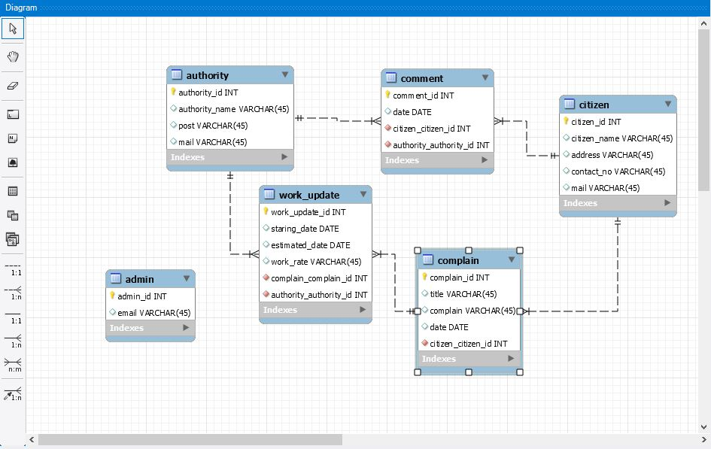

Class Diagram

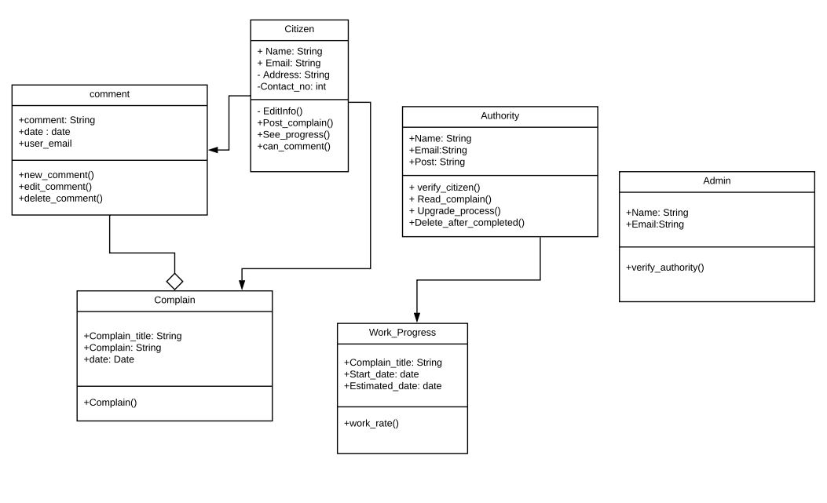

Detail Design

Class Admin

boolean Create_A_Post ( String Name, String email )
admin View_Profile ( String admin_id )

boolean verify_authority ( String authority_Id )
List<admin> Get_Admin_list ( )

Class Authority

boolean Create_New_Authority ( String Name,String Email, String Post )

boolean verify_citizen ( String citizen_Id )

boolean Read_complain ( String post_Id )

boolean Upgrade_progress ( String post_Id )

boolean Delete_after_completed ( String post_Id )

List<Authority> Get_All_Authority _List ( )
Authority View_ Authority _Profile ( String authority_Id )

Class Citizen

boolean Create_New_Citizen ( String Name,String Email, String Address, String Contact_no, String post_Id)

boolean EditInfo ( String Citizen_Id )

boolean Post_complain ( String post_Id )

boolean See_progress ( String post_Id )

boolean Can_comment ( String post_Id )

Class Complain

boolean Complain_title ( String Complain_title)

boolean Complain ( String post_Id )

boolean Date ( date post_Id )

Class Work_Progress

boolean Update_Work_Progress( String Complain_title, date Start_date, , date Estimated_date)
List<Work_Progress> Get_All_Work_Progress_List( String Post_Id )
boolean Comment_On_Work_Progress ( String Post_Id )

Class Comment

boolean comment( String comment, Date date, String user_email)
boolean New_Comment ( String Post_Id )

boolean Edit_Comment ( String Post_Id )

boolean Delete_Comment ( String Post_Id )

List<Comment> Get_Comment_List( String Post_Id)

User Interface

11.1. Index

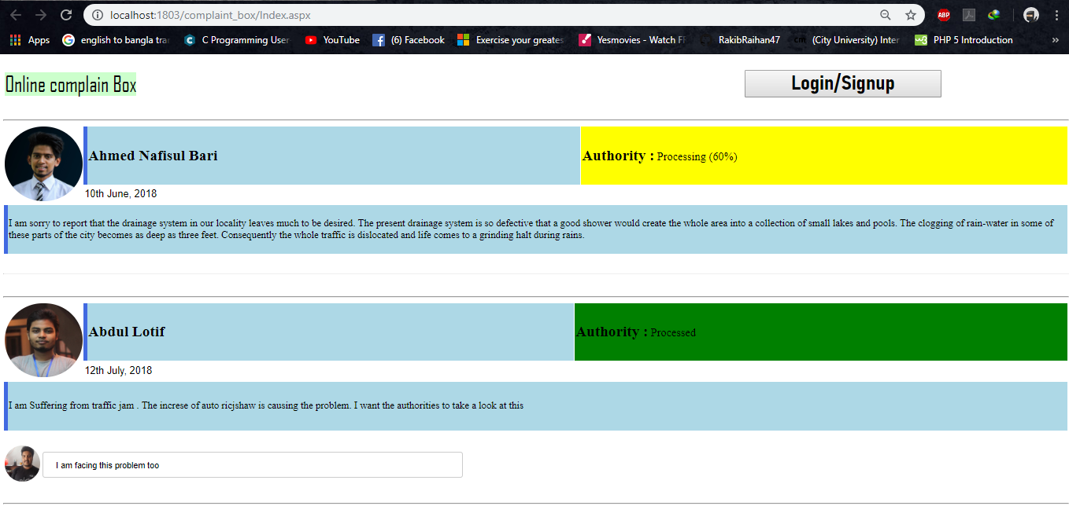

This is the index page of City Corporation Complaint Box. User can see the posts of some recent complains and their comments. In order to posting a complain, user needs to login from this page.

11.2. Signup/Login

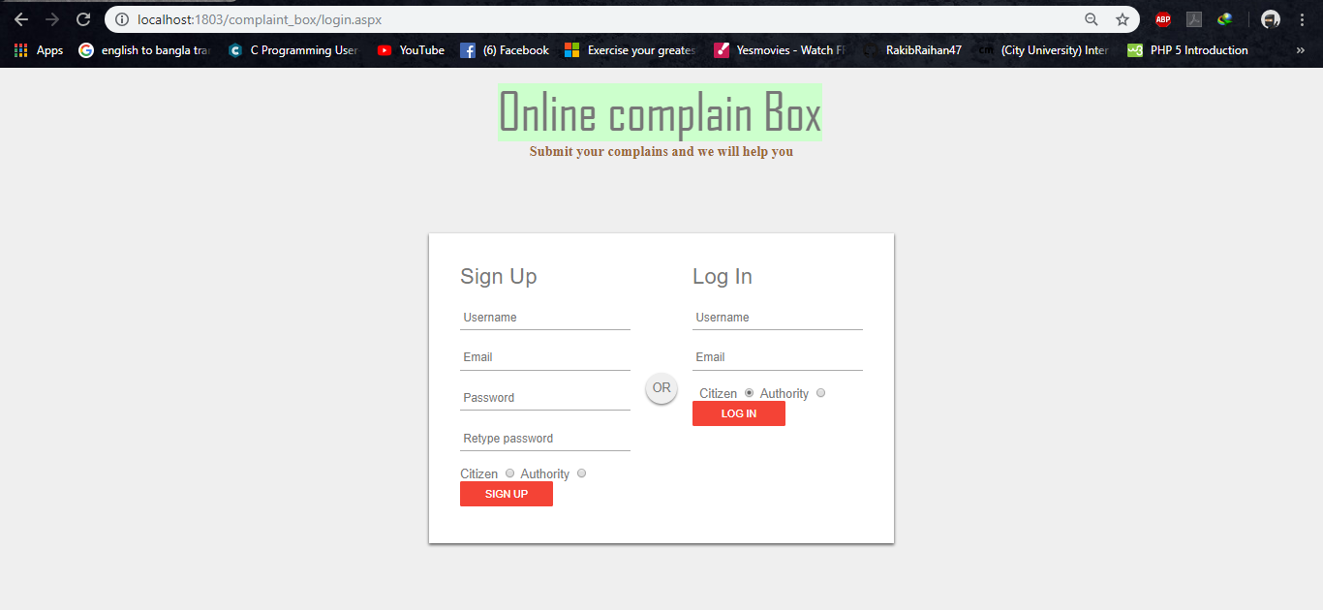

New users can sign up from this page. Existing users can log in from here.

11.3. Home

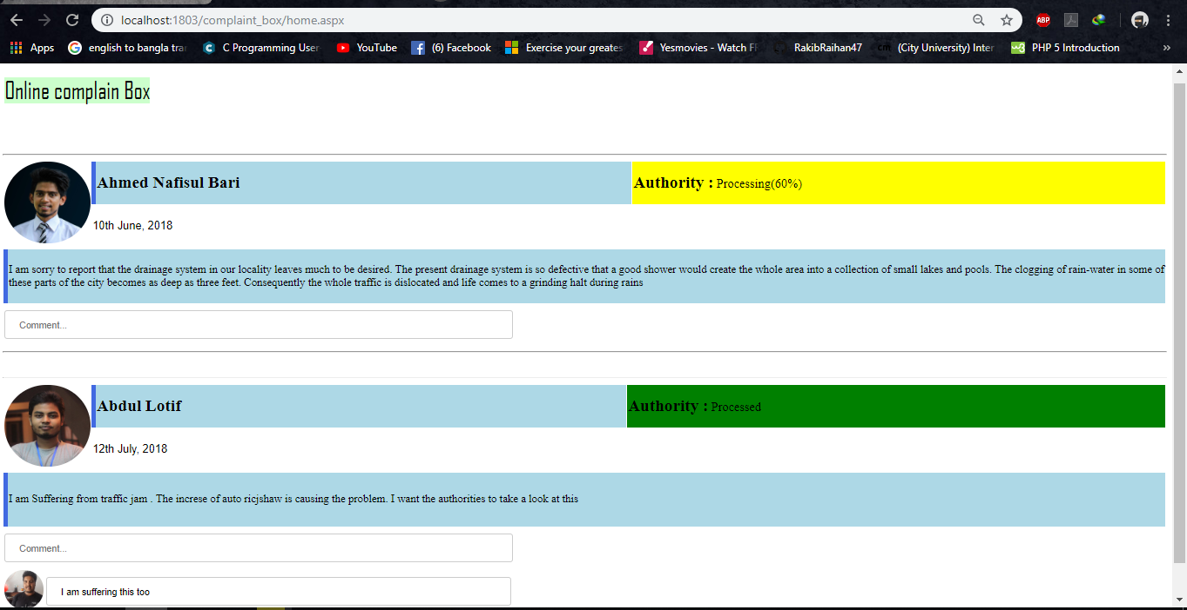

This is the home page of citizens. Citizens can see their complains, working progress and also comment from this page.
11.4. Posting Complains

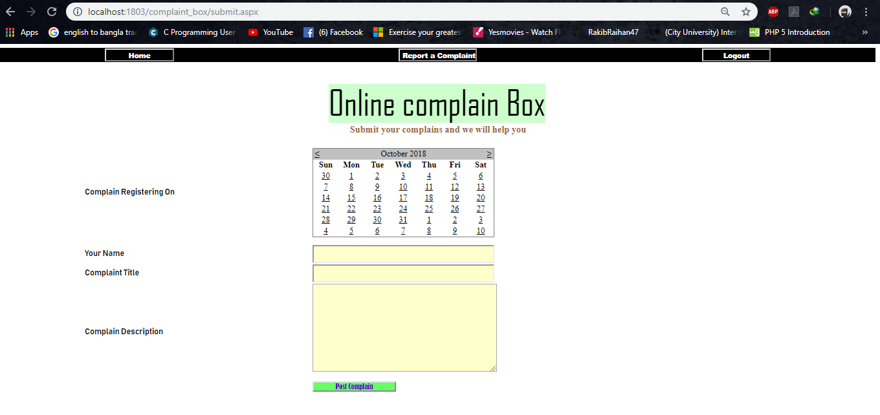

Citizens can post complains from this page.

11.4. Posting Complains

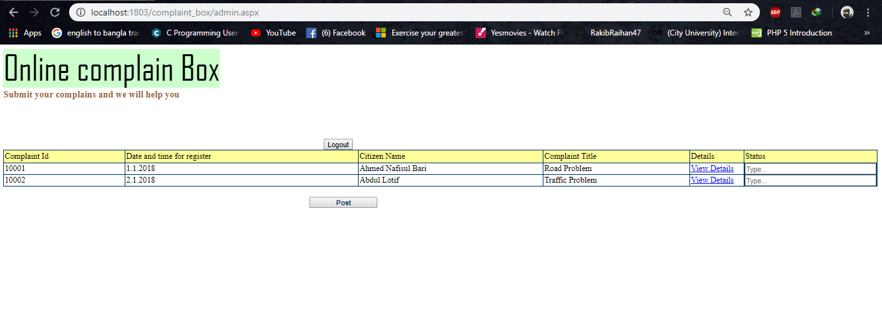

Admins can see lists of Complaint ID, date and time of registration, citizen name, Complaint title, details and status from this page. Admins can also update status of complains.

